34.63: The minimum length mirror for a woman to see her full height h, is 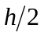, as shown in the figure below.

